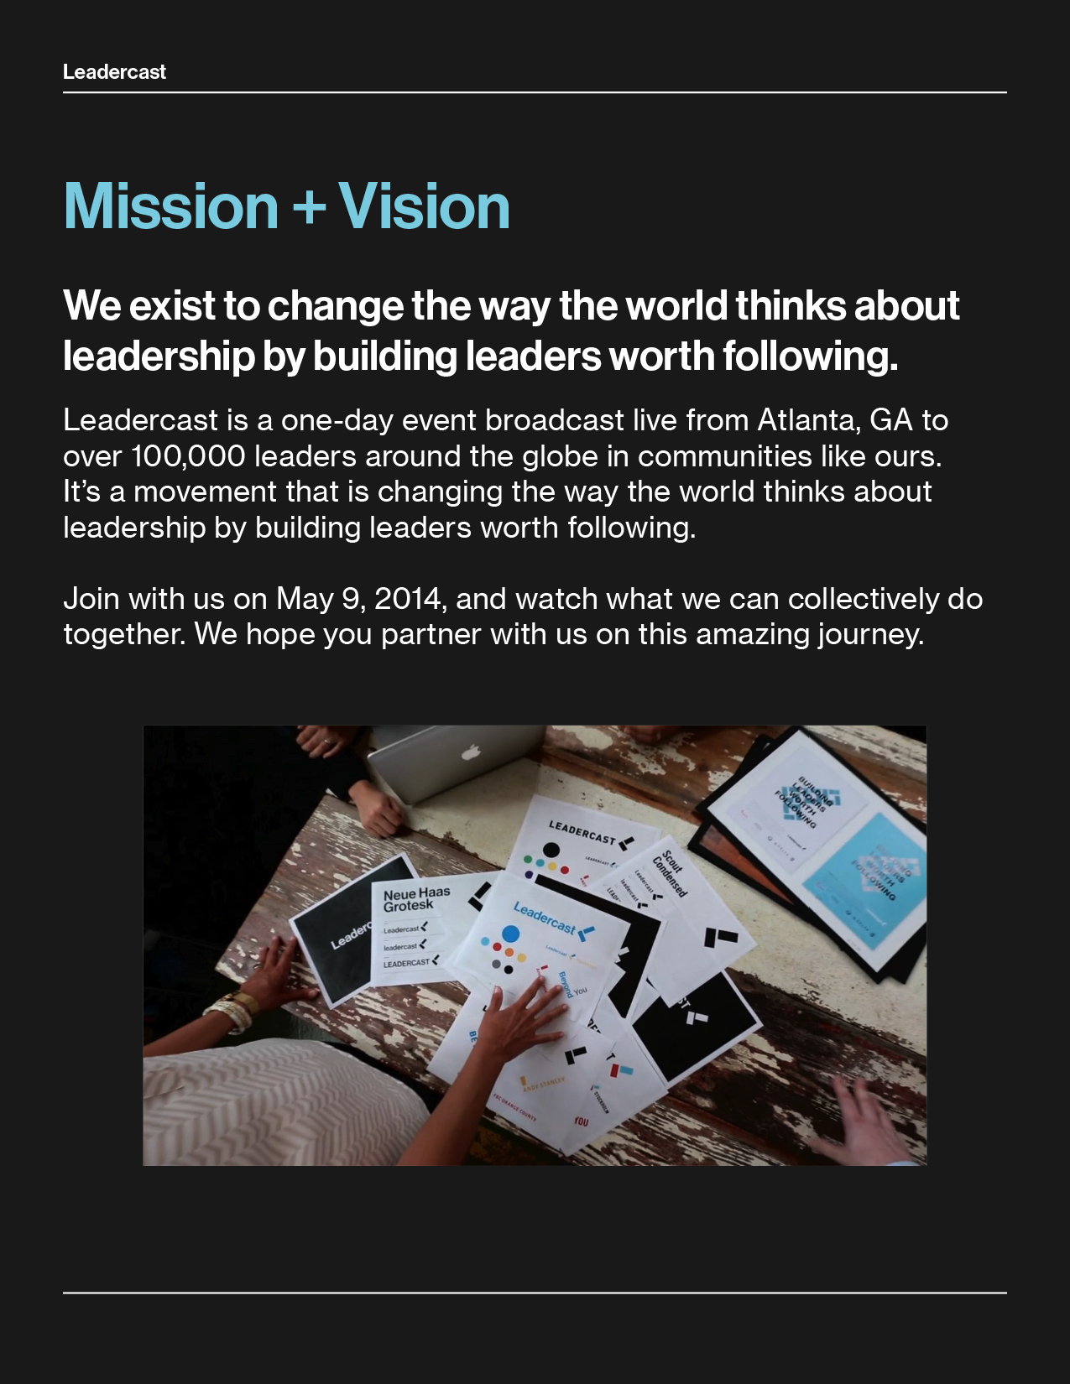

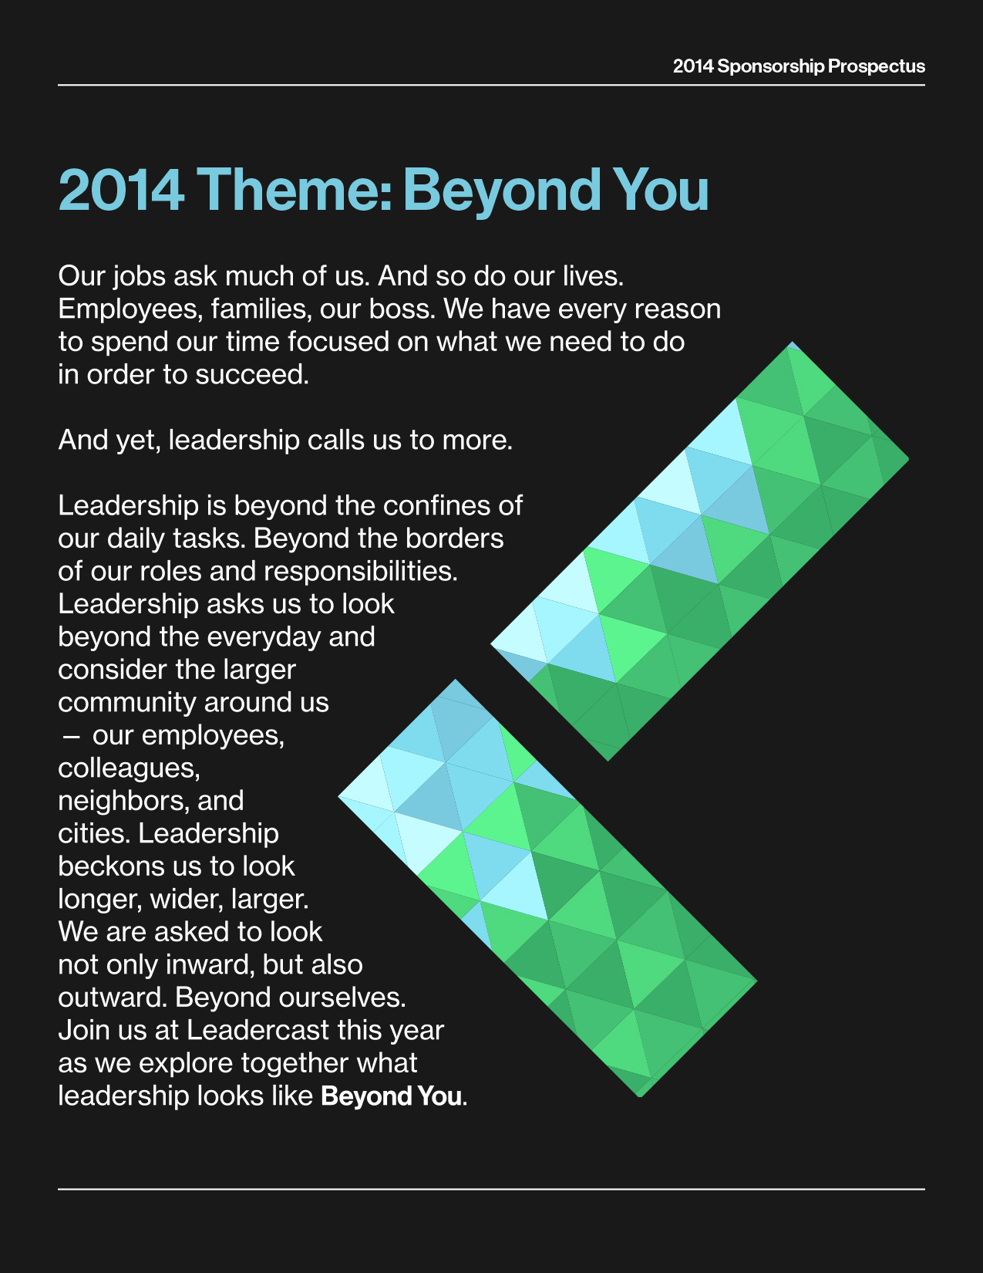

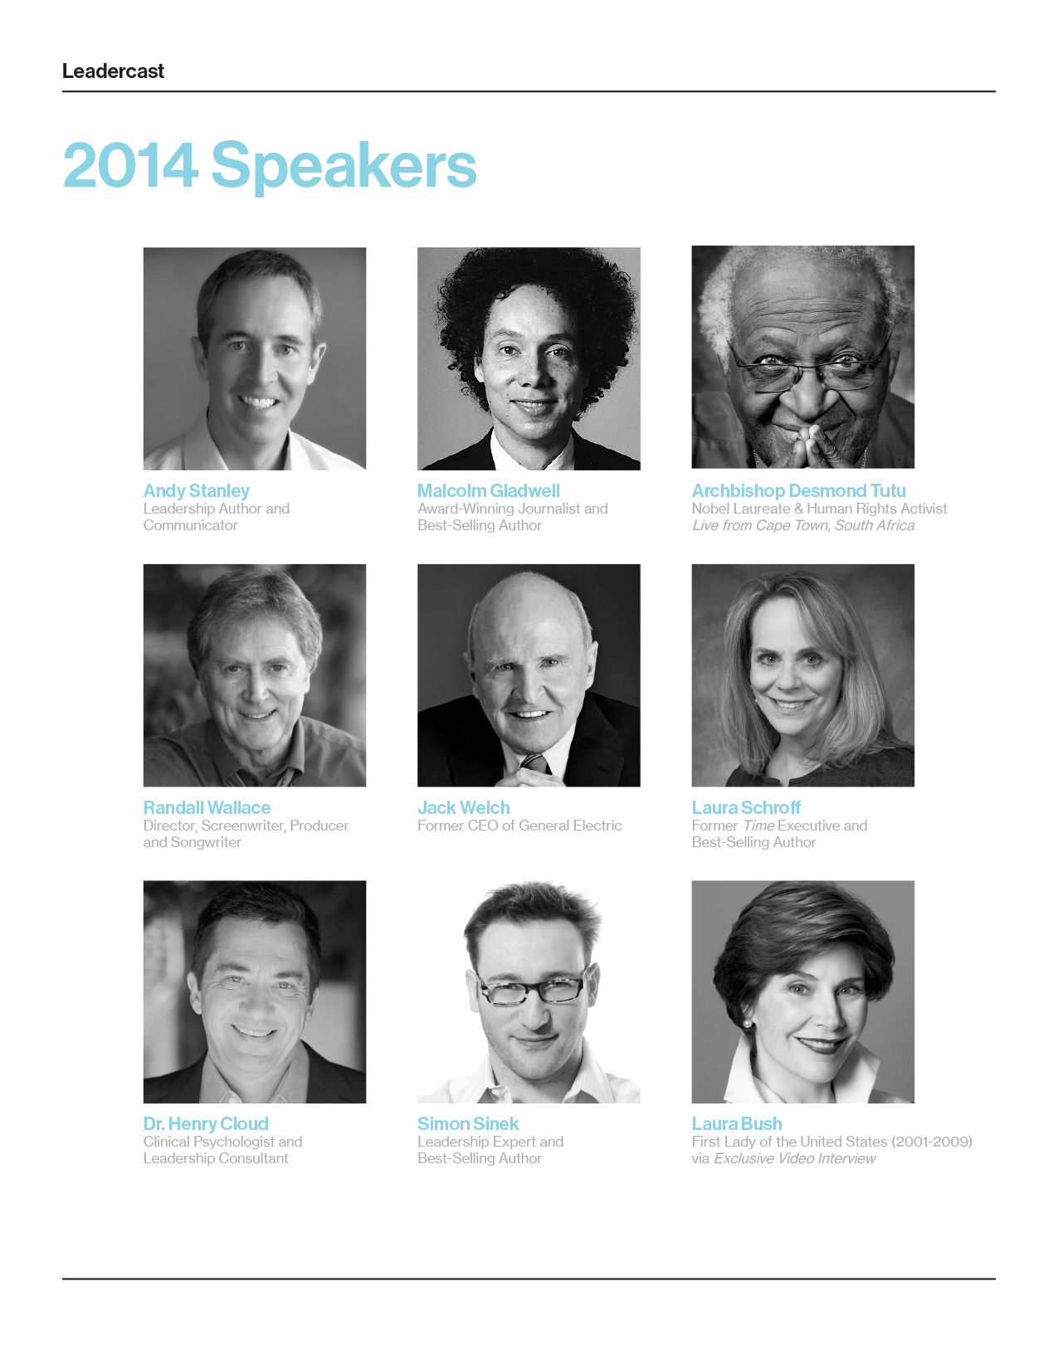

Sponsorship Packages

Platinum Sponsorship – $2,500
- 10 Premium Sponsor Section tickets to Leadercast event.
- Premiere booth location to showcase your products/services
- 1 minute public address to the audience from stage (timing determined by Emcee)
- *Insert, swag, etc. in all attendee bags (Provided by sponsor. See second page.)
- Logo inclusion/verbal recognition on all radio and news media.
- Logo inclusion on all printed marketing material.
- Primary logo placement on Microsite Landing Page
- First right of refusal for sponsorship of 2015’s Leadercast event.

Lunch Sponsorship – $1,500
- 5 Premium Sponsor Section tickets to Leadercast event.
- Inclusion of approved brochures/marketing materials/giveaways in attendee welcome packet
- Booth opportunity to showcase your products/services.
- 1 minute to address audience from the stage before lunch.
- 2 emcee mention during the Leadercast program from stage.
- Logo inclusion on Microsite Landing Page.

Gold Sponsorship – $1,000
- 4 Premium Sponsor Section tickets to Leadercast event
- Inclusion of approved brochures/marketing materials/giveaways in attendee welcome packet
- Booth opportunity to showcase your products/services.
- 2 emcee mention during the Leadercast program from stage.
- Logo inclusion on Microsite Landing Page

Silver Sponsorship - $500
- 2 Premium Sponsor Section tickets to Leadercast event
- Inclusion of approved brochures/marketing materials/giveaways in attendee welcome packet
- Booth opportunity to showcase your products/services.
- 1 emcee mention during the Leadercast program from stage.

Bag Sponsor - $300
- 1 Premium Sponsor Section ticket & Insert in all attendee bags (provided by sponsor) Examples: Coupon, Flyer, Brochure, Pen, Keychain, etc.
All Materials must be dropped off to Colwood Church no later than May 5th, 2014
----------------------------------------------------------------Email / Mail This section back to us

Let’s Get Started:

Business Name: ________________________________________________________

Street Address: ________________________________________________________

City/State/Zip: __________________________________________________________

Phone: ______________________________ Fax:_____________________________

E-mail:___________________________ Contact Name: _______________________

Website Address (If Applicable): __________________________________________

Marketing Piece: _____________________ Promotional Item: __________________

Place an “X” next to your selection:

Platinum ($2,500) ____ Lunch ($1,500) ____

Gold ($1,000) ____ Silver ($500) ____

Bag Sponsor ($300) ____

All tables & chairs are provided. Table Covers are also provided.
For questions and/or other inquiries contact Jenny Maust, at Leader Legacy by email: jenny@leaderlegacy.com .

Sponsor Signature: _____________________________________ Date: _____________

Authorized Event Coordinator Signature: ___________________ Date: _____________

Mail Sponsorship Check and Form to: Leader Legacy Inc.
12340 Timberline Trace North
Granger, IN 46530
For More Information Contact

Justin Maust - Event Director
CEO/President
Leader Legacy Inc. Justin@leaderlegacy.com
574.596.6957

